

Project Report On

**Digital Trash Bin**

**Course No. : CSE 3104**

**Course Title : Peripherals and Interfacing Laboratory**

***Submitted by:***

Md. Tanvir Ahmmed  
Roll: 1807016

Saimoon Al Farshi Oman  
Roll: 1807018

Sadman Sakib  
Roll: 1807020

Department of Computer Science and Engineering

Khulna University of Engineering & Technology, Khulna

***Submitted to:***

**Mohammad Insanur Rahman Shuvo**

Assistant Professor

&

**Md. Motaleb Hossen Manik**

Lecturer

Department of Computer Science and Engineering

Khulna University of Engineering & Technology, Khulna

***Date of Submission:***  26-07-2022

**Contents**

**Objectives** 3

**Problem Statement:** 3

**Introduction:** 3

**Equipment:** 4

**Project Description:** 6

**Flow Chart:** 8

**Circuit Diagram:** 9

**Methodology:** 10

**Discussion and Conclusion:** 11

**References:** 11

**Objectives:**

* To develop a Smart Trash Bin.
* To help to encourage people to clean our environment.
* To digitalize the waste management system.
* To help cleaner to clean the waste when the dustbin is full by notifying them.

# **Problem Statement:**

The main aim of this project is to reduce human resources and efforts along with the enhancement of a smart city vision. We have often seen garbage spilling over from dustbins on to streets and this was an issue that required immediate attention. The proverb “Cleanliness is next to god and clean city is next to heaven” inspired us to conceptualized the project. Smart dustbin helps us to reduce the pollution. Sometimes it appears that garbage dustbin is overflow and many animals like dog or rat enters inside or near the dustbin. This creates a bad scene. This project can avoid such situations. And the message can be sent directly to the cleaning vehicle instead of the contractor’s office.

# **Introduction:**

Every person in this world throws waste in the form of plastics, wet waste, dry waste and etc. Also, every person looks for a place or a plastic container to dispose that waste, that plastic container is the Dustbin which they look for. Dustbin is a plastic container where everyone can dispose their waste. Dustbin is used as a storage place to dispose waste, but we cannot estimate the exact amount of waste disposed by a society, and the dustbin cannot take more waste as the space should be available in it to take more. We need to know the level of waste in the dustbin and based on that we can intimate people to use the dustbin or not.

As one of the fastest urbanizing economies in South Asia, Bangladesh has been facing a rapid growth of waste generation. In the last three decades, waste volume doubled every 15 years. An average of 55% of solid waste remains uncollected in urban areas, with a variation of collection efficiency from 37% to 77%. The ever-increasing hazardous medical and e-wastes add further burden to the ineffective waste management system. Except for some pilot projects, waste is not segregated formally, contributing to piling up waste and creating pressure on landfills which are not managed sustainably. Urban local government authorities are responsible to manage waste, but show a lack of both capacity and commitment toward proper waste management. Dhaka has to deal with around 6,500 tons of waste daily, which is projected to increase to 8,500 tons by 2032.

In this Smart Trash Bin project, we have designed a prototype where the lid of the dustbin is opened, on detection of human hand and waste, and the level of waste available inside the dustbin is sent as notification in the form of LED and periodic buzzer. The main components we used in making this prototype are Arduino, Servo Motor, Ultrasonic Sensors, Buzzer and Bluetooth module. The software component is the application named as Serial Screen Reader which is used to get notification. This dustbin can be a start to Smart Waste Management System where the officials can clean or empty the dustbin which depends on the notification received by them and not waiting for a call from a person of a society who informs the garbage trucks to come and take the waste from them.

# **Equipment:**

**Table-1: Apparatus required for Digital Trash Bin**

|  |  |  |
| --- | --- | --- |
| Serial No | Components | Ratings |
| 1 | Arduino Uno R3 | The operating voltage is 5V  The recommended input voltage will range from 7v to 12V  The input voltage ranges from 6v to 20V  Digital input/output pins are 14  Analog input pins are 6  DC Current for each input/output pin is 40 mA  DC Current for 3.3V Pin is 50 mA  Flash Memory is 32 KB  SRAM is 2 KB  EEPROM is 1 KB  CLK Speed is 16 MHz |
| 2 | HC-SR04 Ultrasonic Sonar Sensor | Power Supply :+5V DC  Quiescent Current : <2mA  Working Current: 15mA  Effectual Angle: <15°  Ranging Distance : 2cm – 400 cm/1″ – 13ft  Resolution : 0.3 cm  Measuring Angle: 30 degree  Trigger Input Pulse width: 10uS  Dimension: 45mm x 20mm x 15mm |
| 3 | SG-90 Servo Motor | Operating Voltage is +5V typically  Torque: 2.5kg/cm  Operating speed is 0.1s/60°  Gear Type: Plastic  Rotation : 0°-180°  Weight of motor : 9gm  Package includes gear horns and screws |
| 4 | Buzzer | Rated Voltage: 6V DC.  Operating Voltage: 4-9V DC.  Rated current: <30mA.  Sound Type: Continuous Beep.  Resonant Frequency: ~2300 Hz.  Small and neat sealed package.  Breadboard and Perf board friendly. |
| 5 | LED | 1.2 to 3.6 volts with a forward current rating of about 10 to 30 mA |
| 6 | Connecting Wired | --- |
| 7 | Breadboard | --- |
| 8 | HC-05 Bluetooth module | Bluetooth protocol : Bluetooth Specification v2.0+EDR  Frequency: 2.4GHz ISM band  Modulation: GFSK(Gaussian Frequency Shift Keying)  Emission power: ≤4dBm, Class 2  Sensitivity: ≤-84dBm at 0.1% BER  Speed: Asynchronous: 2.1Mbps(Max) / 160 kbps, Synchronous: 1Mbps/1Mbps  Security: Authentication and encryption  Profiles: Bluetooth serial port  Power supply: +3.3VDC 50mA  Working temperature: -20 ~ +75Centigrade  Dimension: 26.9mm x 13mm x 2.2 mm |

# **Project Description:**

* The working of the smart dustbin begins when the power supply is given.
* The Smart Dustbin will have an Ultrasonic Sonar Sensor, Servo motor, Arduino UNO, Buzzer, Bluetooth Module, LED and Breadboard.
* All the components are connected to Arduino UNO for processing.
* Basically, the ultrasonic sensors work according to that and if any obstacles come across the smart dustbin detects the obstacles as an input function using echo pin and trigger pin.
* Then, after receiving the input from the ultrasonic sensors, it will notify the user by giving the notification in the form of sound.
* The ultrasonic sensor operates by producing sound waves at a frequency that is too high for humans to hear from the 'TRIG' pin. The 'ECHO' pin is used to wait for sound to be reflected back from a barrier.
* The time is used to calculate the distance between the sensor and the user. The equation distance = (velocity * time) / 2 is employed. The speed of sound (0.030 cm/s) is used here as velocity.
* If any obstacle is within the range and sonar detects it, servo motor operates by given 120 degree angle and it opens the lid.
* Sonar 2 is implemented inside the dustbin to detect the level.
* If trash level is above 40%, yellow led will be turned on to detect a warning level and if trash level is 80%, red light will be on and it will activate the buzzer periodically until trash is taken out.
* Along with activating the buzzer, it will also send message to cleaner by mobile notification.

# 

# **Flow Chart:**

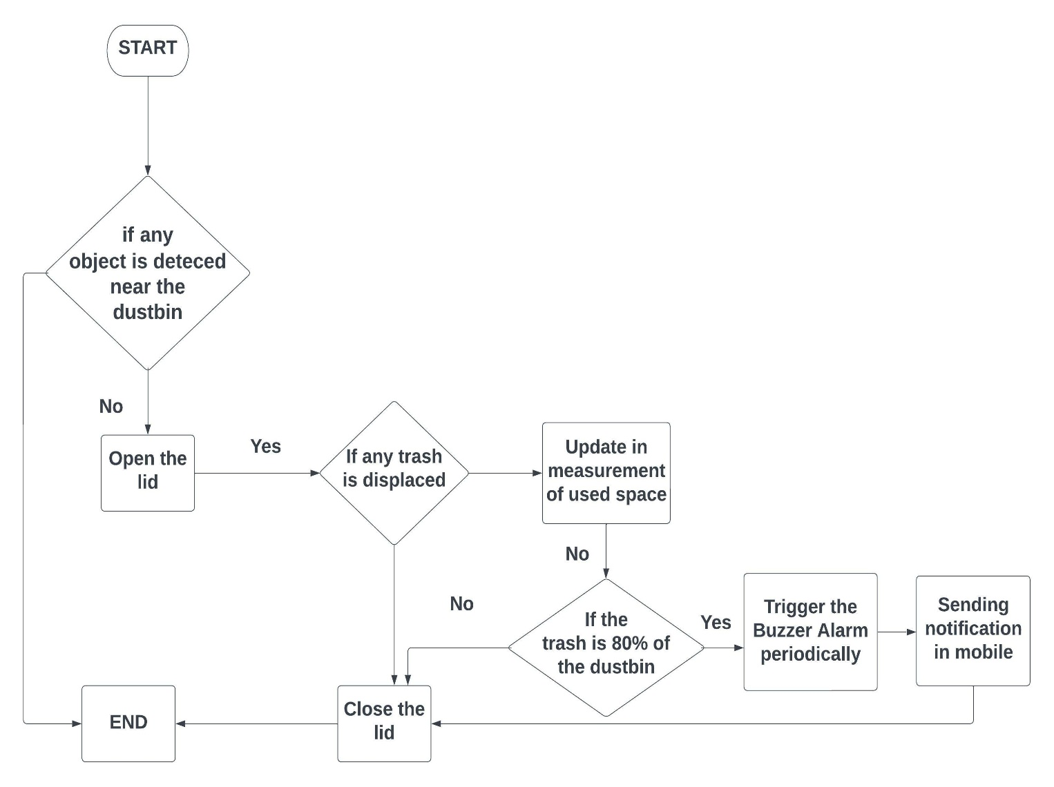

*Figure 1: Flow Chart of Digital Trash Bin*

**Schematic Diagram:**

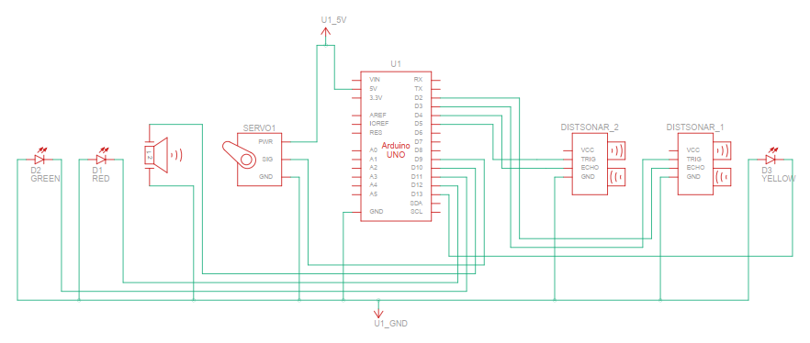

*Figure 2: Schematic Diagram of Digital Trash Bin*

# **Methodology:**

* Firstly pin 2 and 3 of Arduino is connected with sonar1 as echo and trigger pin.
* Then pin 9 of Arduino is connected with servo signal pin.
* Pin 4 and 5 of Arduino is connected with sonar2 as echo and trigger pin.
* Pin 11, 12 and 13 is connected with red, yellow and green led respectively.
* Pin 10 is connected with buzzer.
* Pin RX and TX of Arduino is connected with pin TX and RX of Bluetooth module respectively.
* Sonar1, servo motor, sonar2, led, Bluetooth module, buzzer’s Vcc and ground is connected with Arduino’s 5V and ground pin.

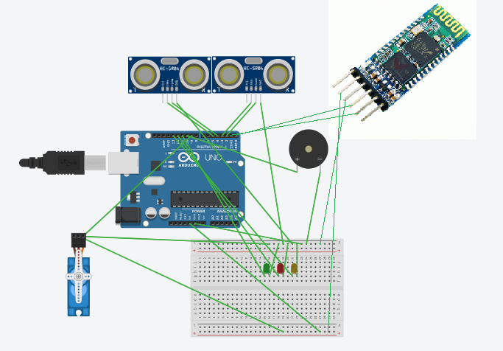

*Figure 3: Circuit Diagram of Digital Trash Bin*

# **Discussion and Conclusion:**

We created a product that can be used to digitalize the waste management system. It will help to clean the waste in time by notifying the trash level to the cleaner. Some important benefit of this project is

* A reduction in the number of waste collections needed by up to 80%, resulting in less manpower, emissions, fuel use and traffic congestion.
* A reduction in number of trash bin needed.
* Maintain environment hygiene (i.e. no overflowing of waste and less unpleasant odor).
* It will help in bringing evolution by technology in term of cleanliness.

Arduino based Smart Trash Bins help the people to manage the waste easily and help them reduce the work of calling or waiting for the specific person to make the area clean and makes a heathier environment to live. They won’t be any kind of diseases and the people will be fit and are not prone to diseases caused by these waste materials. This system assures the cleaning of dustbins soon when the garbage level reaches its maximum. It will take power supply with the help of Battery. If the dustbin is not cleaned in specific time, then the record is sent to the Sweeper or higher authority who can take appropriate action against the concerned contractor. It ultimately helps in keeping the surrounding clean and the waste management can be much easier.

# **References:**

* <https://create.arduino.cc/projecthub/abdularbi17/ultrasonic-sensor-hc-sr04-with-arduino-tutorial-327ff6>
* <https://www.tutorialspoint.com/arduino/arduino_ultrasonic_sensor.htm#:~:text=Advertisements,or%201%E2%80%9D%20to%2013%20feet>
* <https://ozeki.hu/p_2977-how-to-use-a-buzzer-in-arduino.html#:~:text=An%20arduino%20buzzer%20is%20also,reverse%20of%20the%20piezoelectric%20effect>.
* <https://docs.arduino.cc/learn/electronics/servo-motors>
* <https://create.arduino.cc/projecthub/electropeak/getting-started-with-hc-05-bluetooth-module-arduino-e0ca81>